Home Page:
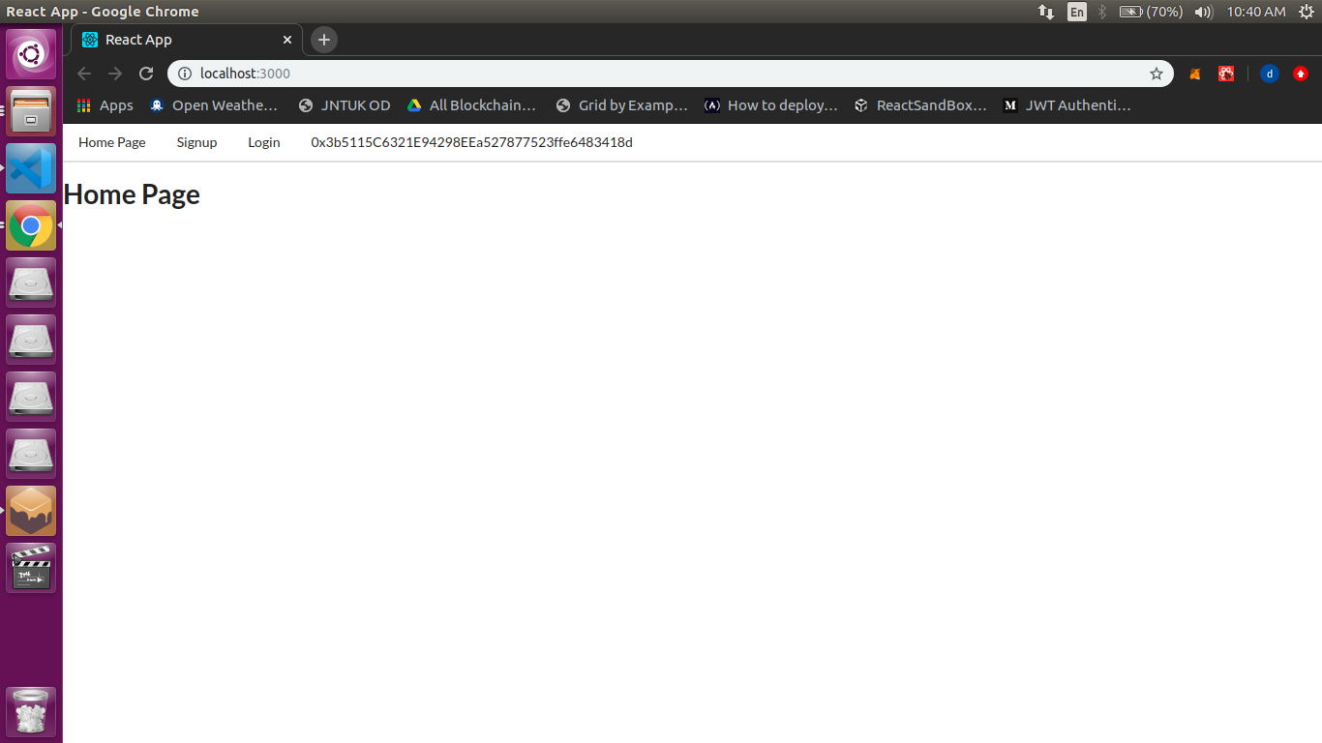

Signup page
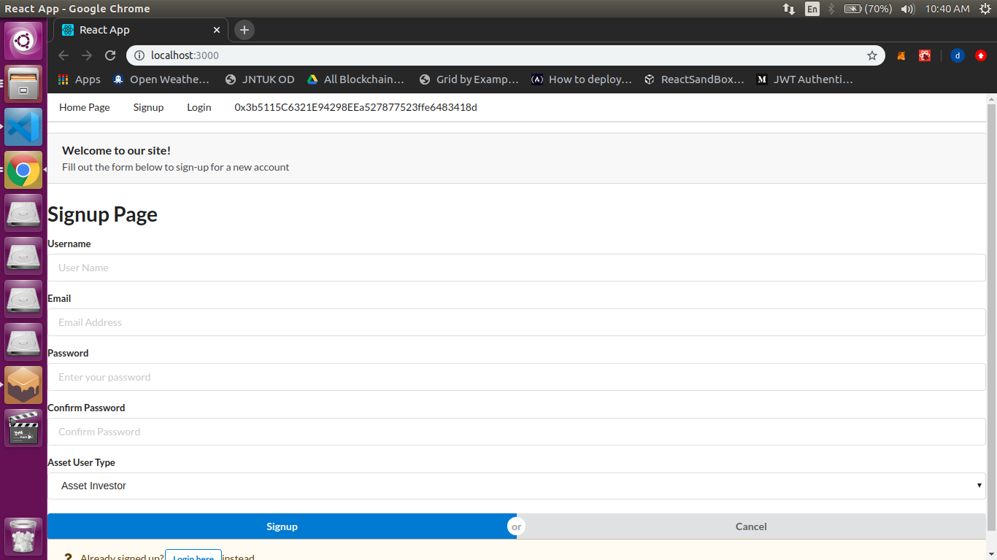

Note: Our “Register” and “Login” should be the same as HeroLedger. Please consult with the team there for the specific fields required. We also want to use the same 2FA. Check with Rahul and Grashias for this information.
I have included some crypto trade exchange screeshots which should help to provide you with additional fields. Also to give you a general idea of what the front end typically looks like so you know what programming to prepare on the backend.

Login Page
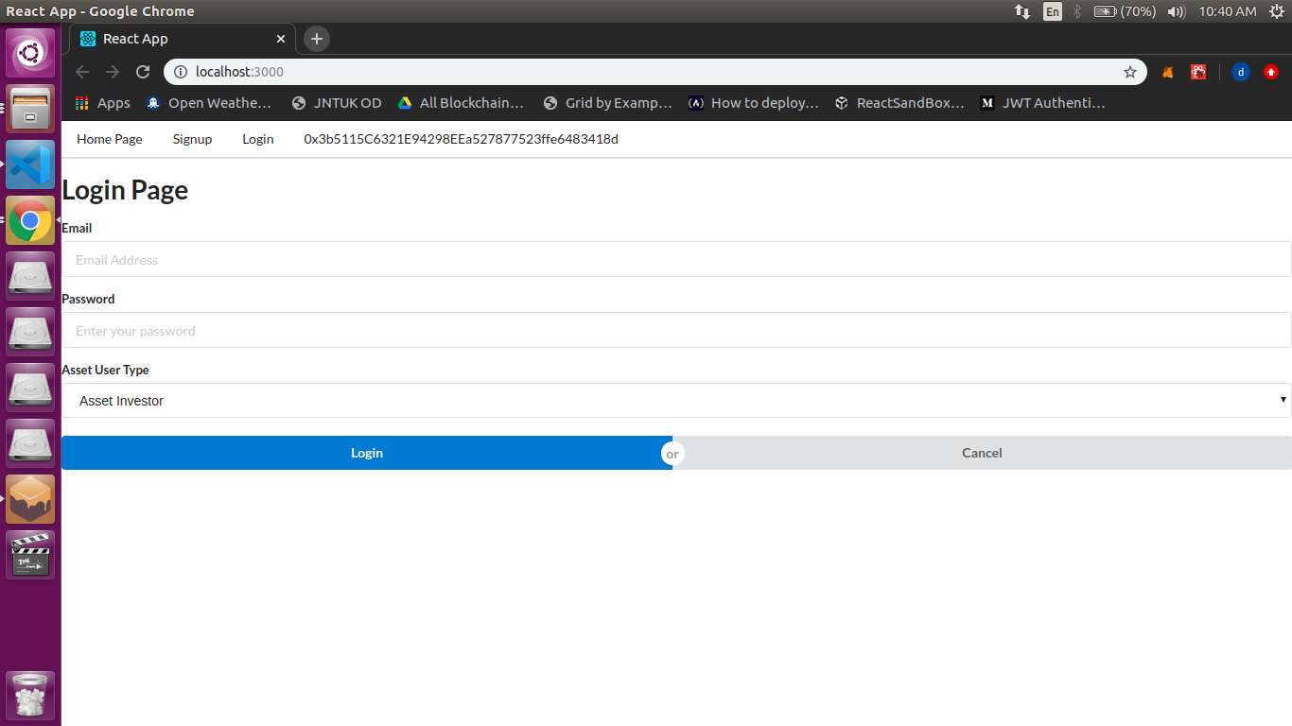
Comic Registration Page:
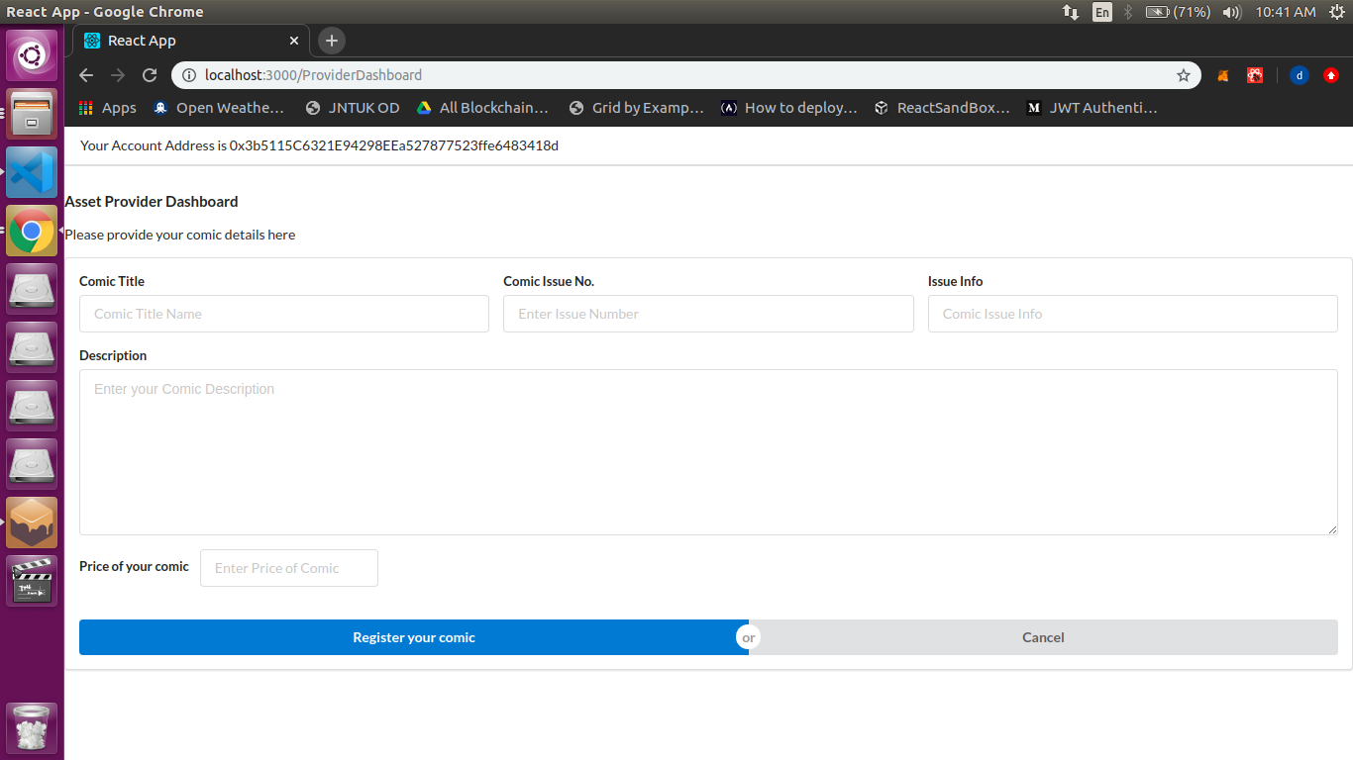
Comic Registration Features:

Feature | GUI | Definition
Comic Title Name Check | Field | ex. Amazing Fantasy
Issue No. Check | Field | ex. #15
Brief Description Check | Field | Limited number of alpha-numeric characters used to provide a brief idea of comic; ex. “First appearance of Spider-Man” or Storyline “Age of Apocalypse”
Full Description Check | Field | Area for full alpha-numeric descriptions on comic asset(s) investment
Grade Check | Field | represents an alpha-numeric code used by comic book graders to estimate/state the condition of the physical good (ex. VF-NM “very fine, near mint”)
Grade ID Check | Field | represents an alpha-numeric numbering system used by comic book graders to show they have appraised the physical good
Grader Info Check | Field | Who appraised the comic and their contact info
Declared Value Check(As Price) | Field | Dollar amount representing the comic book(s) value (ex. $45.00)
Investment type Check | Dropdown (equity , bond, fund, Futures) | Asset Provider “Issuer” uses this button to determine they want to make one or more of their comic books available as a percentage of ownership in
Share / Deb Allocation Check | Field | Asset Issuer inputs a numeric representation of the number of shares / bonds they are making available to investors; percentage of issuance should automatically show next to input
Price per Share / Bond Check | Field | Asset Issuer inputs a dollar amount representing price per share / bond they are making available to investors
Voting Stipulation Check | Check Boxes | Asset Issuer chooses whether the digital asset will be “public” or “private” to vote on
Ticker Symbol Check | Field limit word(4 characters), No symbols | Alpha-numeric field Asset Issue assigns a 3-4 letter identifier to their digital asset

Comic Investor buying comic page
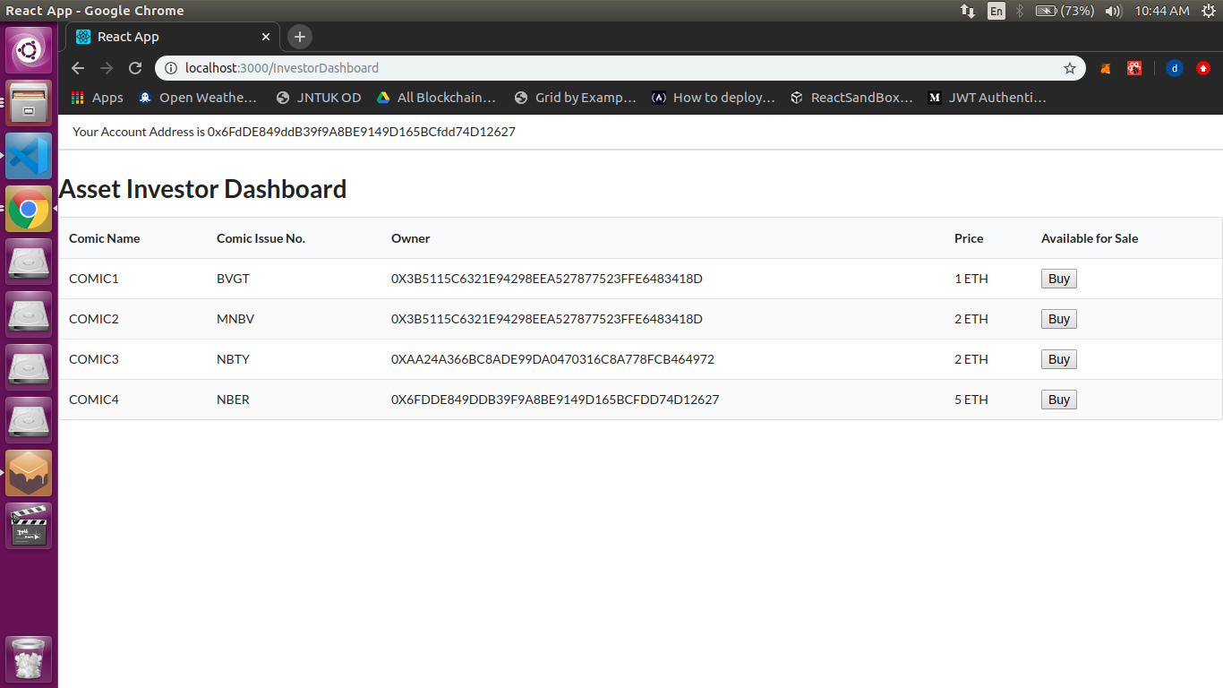
Note: Asset Issuers and Asset investors should see an area on their dashboard showing their transaction types that is, transactions with assets they have issued, purchased or sold on the exchange. All assets should show the outstanding amount if the asset shares/bonds are not sold out. (ex. 400 shares purchased / 1500 shares issued).
On the System User’s Dashboard no more than 5 transactions should show. They should have the option of “Show More” to see the full list of assets. Meaning we can see 15 transactions on one dashboard page; 3 sections with five transactions each for: Issued, Purchased, Sold.

Issued and Sold are not the same. Issued represents digital assets the system user personally structured for purchase on the exchange. Sold represents any assets the system user has personally sold acquired from another system user. As “Buy” represents what the system user has purchased on the exchange from another issuer or investor.
Table should look like the following:

DateTime Stamp- Check | Ticker Symbol- Check | Hash | Price per share- Check | Amount of shares- Check | Outstanding (Remaining) Shares | Total Price Paid | Trxn Fee (Fee which system sets for user)

Visual Examples:
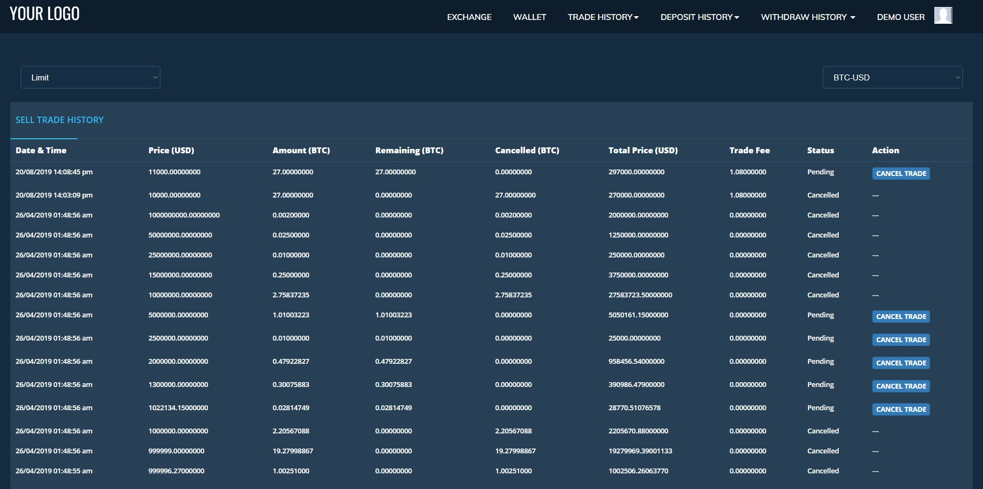

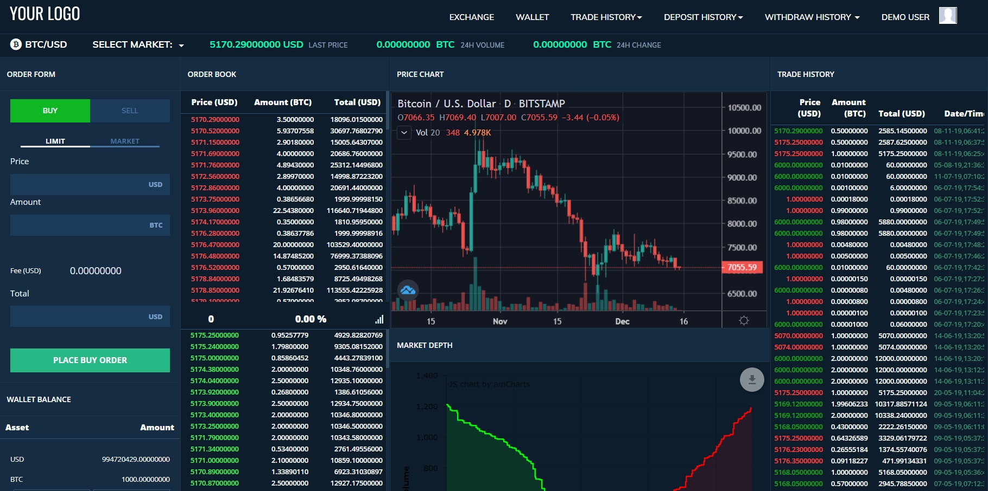

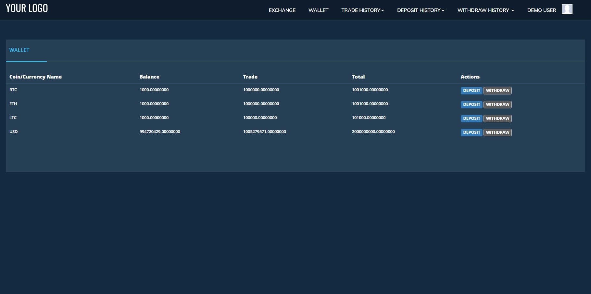

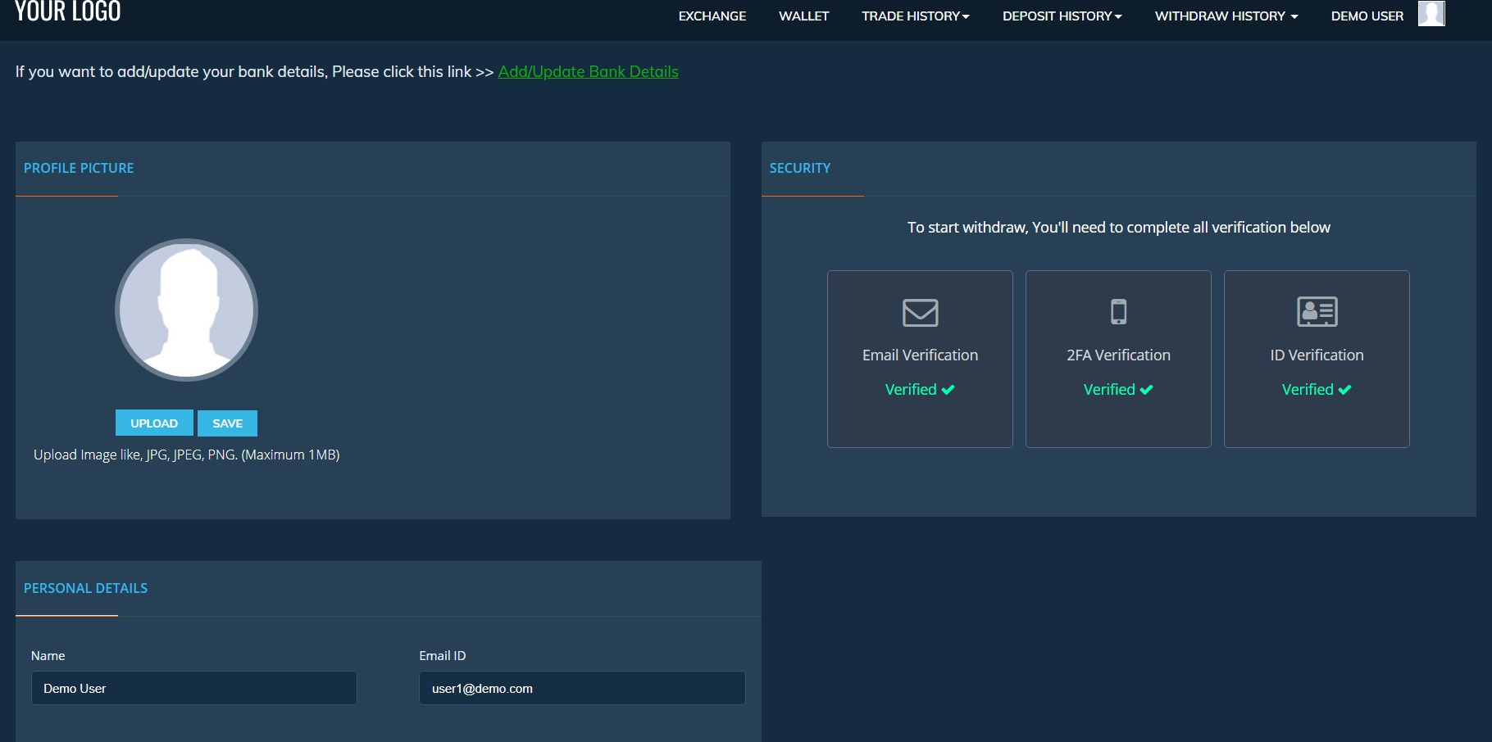
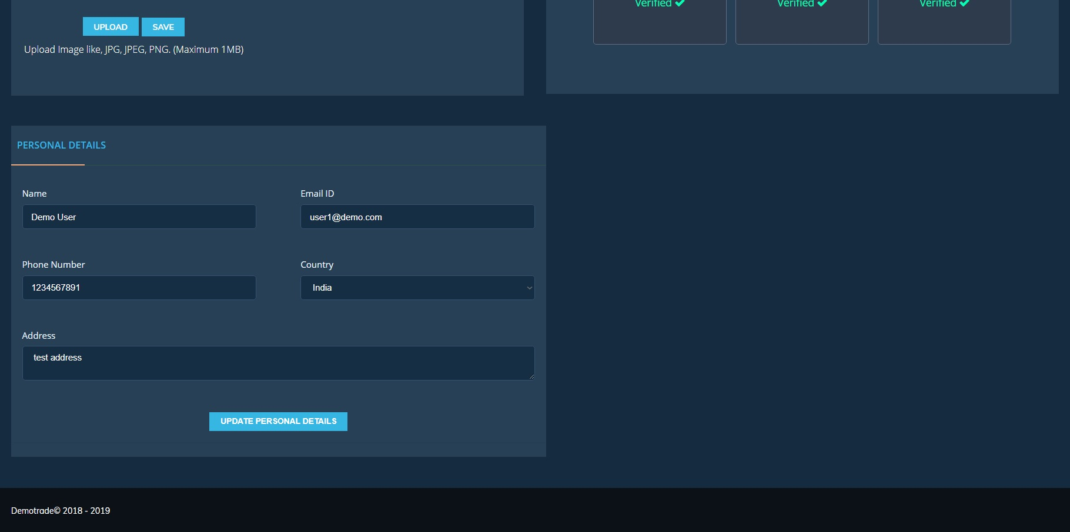
got 3 comics and add all 3 comics value – Edit the comic using the state -upload a photo

